Lesson 1 Demo 4: ReplicaSet Creation

This section will guide you to:

* Create ReplicaSets using a yaml file

This lab has one sub-section, namely:

1. Creating ReplicaSets using a yaml file

**Note:** If you don’t have an existing Kubernetes cluster, refer to the Demo 1.1 of Lesson 1.

**Step 1:** Creating ReplicaSets using a yaml file

* On the master node, create a new yaml file

*vi frontend1.yaml*



* Add the following code into the **frontend1.yaml**file:

*apiVersion: apps/v1*

*kind: ReplicaSet*

*metadata:*

*name: frontend*

*labels:*

*app: guestbook*

*tier: frontend*

*spec:*

*# modify replicas according to your case*

*replicas: 3*

*selector:*

*matchLabels:*

*tier: frontend*

*template:*

*metadata:*

*labels:*

*tier: frontend*

*spec:*

*containers:*

*- name: php-redis*

*image: gcr.io/google_samples/gb-frontend:v3*

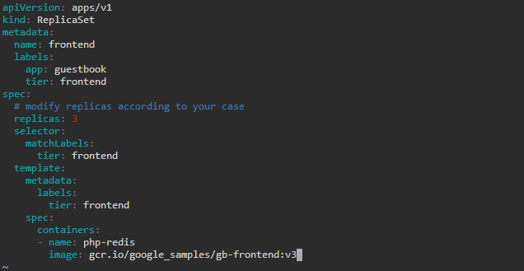

**Note:** Press **Esc** button and enter **:wq** to save and exit the text editor

* Create the defined ReplicaSet and the pods that it manages

*kubectl apply -f frontend1.yaml*



* List the currently deployed ReplicaSets

*kubectl get rs*



* Use the following command to check the state of the **frontend** ReplicaSet

*kubectl describe rs/frontend*

